**Storing on Hadoop**

1. I have installed Hadoop on an Azure VM already, So I copy the files onto my VM



1. Then the files must be added to Hadoop





1. Loading and cleaning data with pig.
   1. Create the file tmdb_clean_text.pig



* 1. Loading the CSV

* 1. Remove Rows with Missing 'id' or 'name'

* 1. Remove Duplicates

* 1. Remove Invalid or Null 'first_air_date'

* 1. Normalize 'adult' Column (Convert to Boolean 'true' or 'false')

* 1. Remove Unreadable Characters (Non-ASCII)

To do this, I created a Java UDF “CleanText.java”.

Then compile and create a JAR.





Then add the lines to the script.

* 1. Store the Cleaned Data in HDFS

1. Running the script and Issues

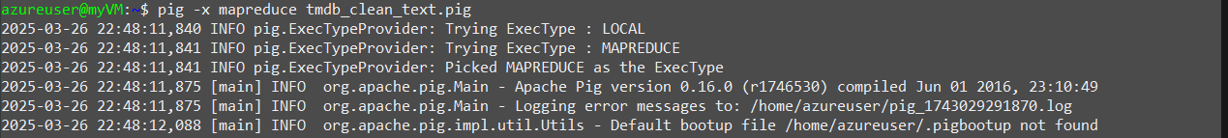

As you can see from the screenshot, there is only one entry left in the database. I believe this is because of the structure of the original dataset, which has some missing values as well as a column called “languages” that has multiple values per row that throws off how pig expects to read a csv. There was no easy fix that was readily apparent, so we decided to switch our approach to using MongoDB and python.